**Protect Yourself from Air Pollution**

Air pollution is a mixture of particles and gases that cause or worsen heart disease when inhaled. Even short-term exposure can increase your risk of heart failure or heart attack.

Causes of air pollution

* 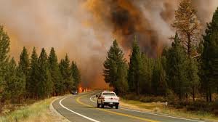Wildfires, wood fires or brush fires
* Construction sites
* Vehicle and industrial emissions
* Heating and cooking appliances
* Tobacco smoke

Ways to protect yourself

* Use a portable air cleaner indoors to remove pollutants from your home
* Attach a filter to your furnace or HVAC system to prevent pollutants from entering your home
* Keep windows and doors shut when the Air Quality Index is high
* In the car, use the air conditioning and recirculating air options
* Use an N95 or N99 mask outdoors to reduce inhaled pollutants
* 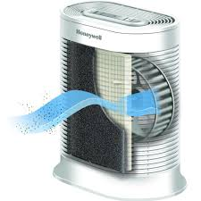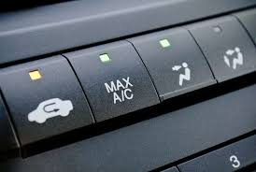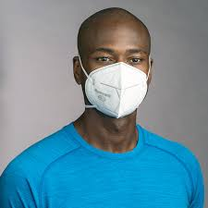Limit outdoor activity or exercise when air quality is poor