**Protect Yourself from Heat Risk**

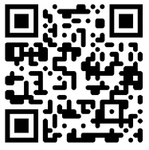Heat can make your health worse if you suffer from heart failure. Go to the ***CDC HeatRisk Dashboard*** to find your local heat level

Symptoms of Overheating:

* 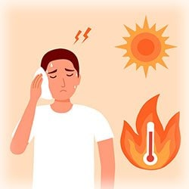Muscle cramping
* Shortness of breath
* Dizziness or weakness
* Headaches
* Nausea
* Excessive sweating

Ways to protect yourself

* Stay hydrated by drinking water and limit beverages with high levels of sugar, salt, caffeine or alcohol
* Perform outdoor activities during cooler parts of the day, like early morning or evening
* When indoors, use air conditioning or visit a cooling center
* Have a plan for what to do with refrigerated medications or electronic medical devices in the event of a power outage
* Check the Air Quality Index before planning outdoor activity
* 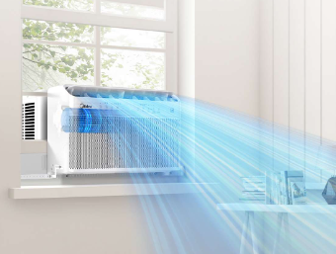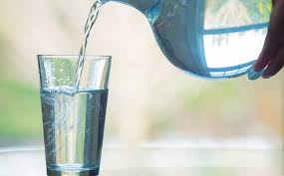Take breaks when possible during times of high heat